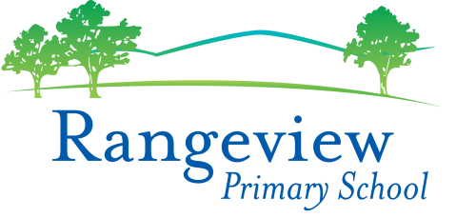ASSESSMENT AND REPORTING POLICY

Philosophical Basis

Assesment and reporting will be undertaken within DET guidelines. Assessment is an integral part of the educational process. Information is acquired which relates to the student’s progress and the aims of the policy and programs.
Reporting to students and parents will communicate the achievements of students, and will provide recommendations which assist the student’s future learning. Co-operation and communication concerning the student’s progress between parents, teachers and students is encouraged.

Guidelines

Assessment

1.1 Assessment should be objective and include a wide variety of assessment tools which will cover many aspects of knowledge from the skills acquired and applied to the attitudes and understandings communicated.
1.2 Individual student files will be maintained regularly and include written information on assessed tasks and relevant profile documentation.
1.3 At Rangeview we follow an agreed Assessment Schedule Foundation to Grade 6.
1.4 At the end of each semester, teachers will record agreed assessment data to be entered into the Sentral Database.
1.5 All students will have an Individual Learning Portfolio that is viewed by parents at the mid-year Student Led Conference. This is taken home by students at the end of the year.
Reporting
2.1 Parent and Teacher discussions will be held early in Term 1.
2.2 Student Led Conferences will be held at the end of Semester 2.
2.2 Student Reports will be provided at the end of Semester 1 and 2 and are published online on the Sentral Parent Portal. Copies of student reports will be maintained on the Sentral system until the student exits the school.
2.3 Student Reports should indicate what has been achieved by the student including recommendations for future learning.
2.4 NAPLAN results are provided to parents only in Term 3 of Level 3 and Level 5. NAPLAN certificates are not stored at the score beyond this time and cannot be accessed by the school again.

Review Date
This policy was last updated August 2019 and is scheduled for review in 2022

