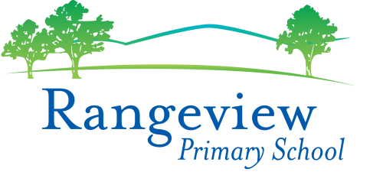
Inclusion and Diversity Policy
Rationale:
The purpose of this policy is explain Rangeview Primary School’s commitment to making sure every member of our school community, regardless of their background or personal attributes, is treated with respect and dignity. Rangeview Primary School strives to provide a safe, inclusive and supportive school environment for all students and members of our school community.

Definitions:
Personal attribute: a feature of a person’s background or personal characteristics that is protected by State or Commonwealth anti-discrimination legislation. For example: race, disability, sex, sexual orientation, gender identity, religion etc.

Inclusion and diversity
Rangeview Primary School is committed to creating a school community where all members of our school community are welcomed, accepted and treated equitably and with respect regardless of their backgrounds or personal attributes such as race, language, religious beliefs, gender identity, disability or sexual orientation so that they can participate, achieve and thrive at school.
Rangeview Primary School acknowledges and celebrates the diversity of backgrounds and experiences in our school community and we will not tolerate behaviours, language or practices that label, stereotype or demean others.
Rangeview Primary School will:
- ensure that all students and members of our school community are treated with respect and dignity
- ensure that students are not discriminated against and where necessary, are accommodated to participate in education and all school activities (eg schools sports, concerts, assemblies and excursions) on the same basis as their peers
- acknowledge and respond to the diverse needs, identities and strengths of all students
- encourage empathy and fairness towards others
- challenge stereotypes that promote prejudicial and biased behaviours and practices
- contribute to positive learning, engagement and wellbeing outcomes for students.
Bullying, harassment and other forms of inappropriate behaviour targeting individuals because of their personal attributes will not be tolerated in our school community. Students who may have experienced or witnessed this type of behaviour are encouraged to speak up and to let their teachers, parents or carers know about those behaviours to ensure that inappropriate behaviour can be addressed.
Rangeview Primary School will take appropriate measures, consistent with its Student Engagement and Wellbeing and Bullying policies to respond to discriminatory behaviour or harassment at our school.
Rangeview Primary School also understands that it has a special obligation to make reasonable adjustments to accommodate students with disabilities. A reasonable adjustment is a measure or action taken to assist all students to participate in their education on the same basis as their peers. Reasonable adjustments will be made for students with disabilities through our Student Support Group processes in consultation with the student, their parents or carers, their teachers and if appropriate, their treating practitioners. For more information about support available for students with disabilities, please refer to our school’s Student Engagement and Wellbeing Policy or contact the school for further information.
Related Policies Documents
Student Engagement and Wellbeing Policy
Bullying, Cyber Bullying and Harassment Policy
School Policy and Advisory Guide:
  - Inclusive Education
  - Koorie Education
  - Teaching Aboriginal and Torres Strait Islander Culture
  - Safe Schools
  - Supports and Services
  - Program for Students with Disabilities
Review Date
This policy was last updated September 2018 and is scheduled for review in 2021

