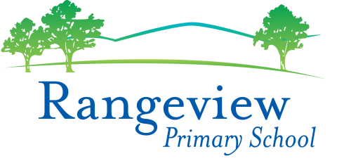
School Uniform Policy
Philosophical Basis

A uniform dress code reinforces in students a pride in their own appearance, instils recognition of themselves as an integral part of the school community, and assists in developing pride in representing their school. Issues of equality, health and safety, and expense are also factors that contribute to the establishment of the dress code.
Guidelines
1.1 The School Council and the Junior School Council, will develop a dress code that provides choice for the students, allows for students to safely engage in the many varied school activities, and caters for the financial constraints of families.
1.2 The dress code applies during school hours, whilst travelling to and from school, and when students are on school excursions.
1.3 Summer and winter uniforms will be prescribed and are required to be worn.
1.4 Jewellery must be kept to a minimum – stud earrings/sleepers and watches – and must comply with safety requirements.
1.5 Extreme hair colours (e.g. Green, pink or purple rinses) and/or extreme hairstyles (e.g. Mohawks) are not permitted.
1.6 Cosmetics may not be worn at school. Clear nail polish only.
1.7 Sunsmart blue hats, consistent with our sunsmart policy, must be worn outside from 1st September until the end of April. Hats are not to be worn inside. Headbands should be discrete and consistent with school uniform colours.
1.8 Non school uniform items e.g. coats, scarves and beanies are not to be worn during class time.
1.9 The school will operate a scheme for good quality second hand uniforms, and will operate a second hand uniform store for parents.
1.10 The student dress code, including details of uniform items and places of purchase, will be published in the newsletter at the start of each year.
1.11 School Council requires the Principal with support from staff to be responsible for implementation of the dress code in a manner consistent with the Code of Student Behaviour.
1.12 Arrangements can be made to supply uniforms via State Schools Relief for families experiencing economic hardship.

1.13 Parents seeking exemptions to the dress code due to religious beliefs, ethnic or cultural background, student disability, health conditions or economic hardship must apply in writing to the Principal. These exemptions will be granted consistent with Department of Education and Early Childhood Development student dress code.
1.14 Footwear should be appropriate for school activities and should be black or white e.g. no thongs or high heeled shoes.
1.15 Sports t-shirt with the Rangeview logo introduced in 2019 can be worn by grades 4-6 students on PE days and school sports days excluding House Sports Day.
1.16 School Bags will be the Rangeview navy bag only from the beginning of 2020 for Foundation students with gradual implementation across the school in subsequent years.
1.17 Any changes to school uniform should be phased in over an appropriate time period determined by the Principal and School Council.

Appendix: The Rangeview School uniform consists of the following: green shorts, green track pants, blue polo shirt, blue and green sports shirt (grades 4 – 6) blue rugby jumper, blue softshell jacket, blue bomber jacket, blue/white summer dress, blue/green winter dress, blue leggings and blue slouch hats.
Review Date
This policy was last updated May 2019 and is scheduled for review in 2022

