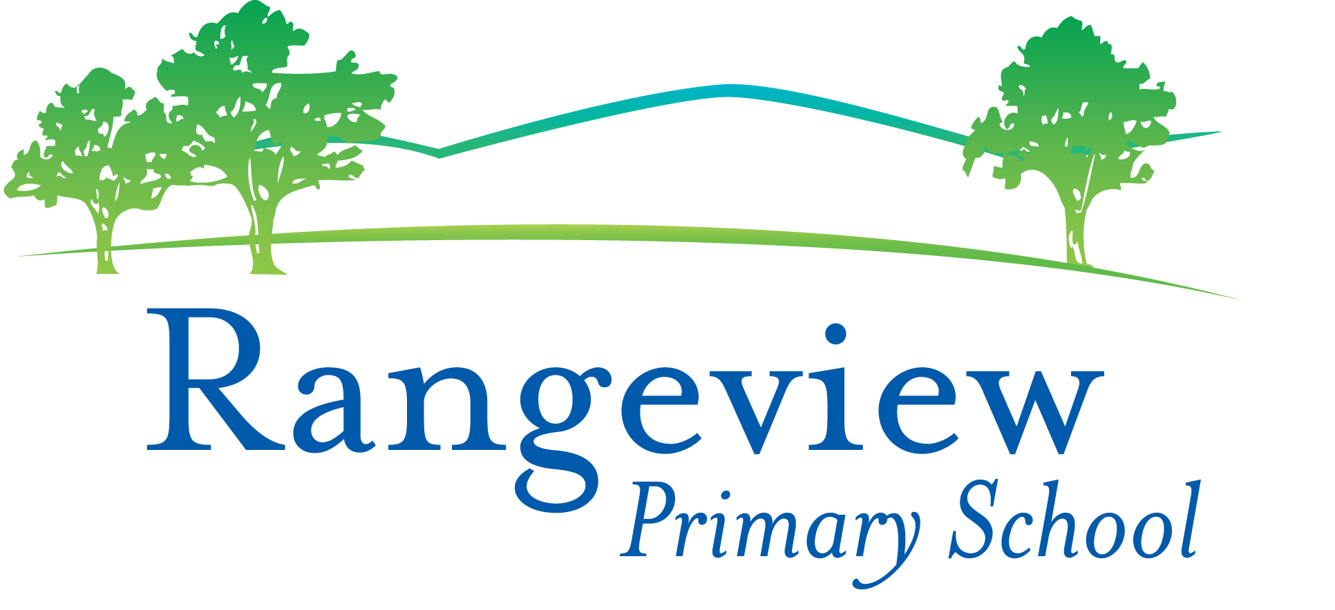
Level 1 App List 2020
Updated 29/1/20
You will see that the Apps have been organised into folders. For Level 1 students, Parents, please create these folders and put the apps in the appropriate folder: MATHS, WORD WORK/ ENGLISH, STORY, CREATIVITY, SETTINGS, PRODUCTIVITY. Please put all other apps into the SETTINGS folder or UTILITIES folder. You may like to create a HOME folder for apps you use at home.
Please put the Safari icon, the Camera icon, the Showbie and See Saw icon on the bottom bar of the iPad.
There are essential Apps on the Whole School App List that you should already have. Please check this on the Rangeview Website. Mathletics, Reading Eggs, Quick Voice Recorder, Showbie, Book Creator, Popplet, Pic Collage are some of the essential apps from the whole school app list.
To create a folder, press and hold one of the apps so that they start to shake. You can then:
- Create a folder by dragging and then holding one app on top of another. You can then rename the folder.
- Add an app to a folder by dragging an app so that it is on top of a folder
When you've finished, press the Home button to stop the shaking.
MATHS Folder
App | Cost |  | App | Cost
Scratch Jnr  (from Foundation) | Free | 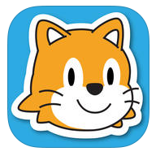 | Mad Math 2  (from Foundation) | $2.99 | 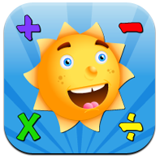
100 Yay!  (from Foundation) | Free | 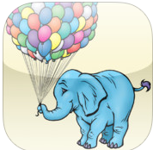 | Slate Math  (from Foundation) | Free | 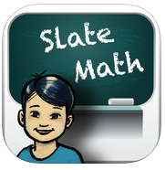
Number Pieces Basic | Free | 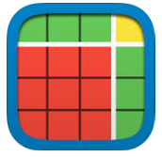 | Find Sums – search for this under iPhone apps | Free | 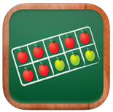
Fractions | Free |  | Telling the Time Ages 6-8: Andrew Brodie Basics | $5.99 | 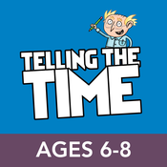
Quick Math Jr | Free | 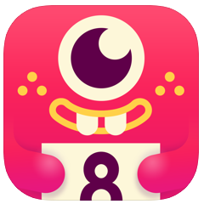 | Pattern Shapes | Free | 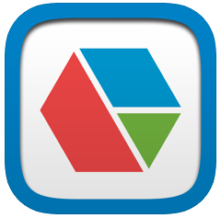
Math Balance | Free | 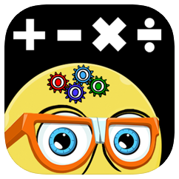

WORD WORK / ENGLISH Folder
rED Writing  (from Foundation) | $4.49 | 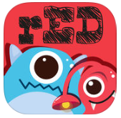 | Word cookies | Free
Montessori Rhyme time | Free | 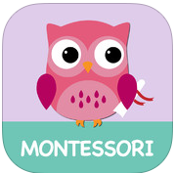 | Rhyming Bee  (From Foundation) | Free | 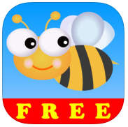
Phonics Fun 4 (from Foundation) | Free | 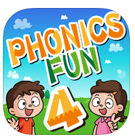 | Phonics Fun 5 | Free | 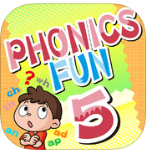
Phonics Fun 6 | Free | 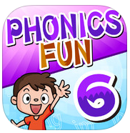

CREATIVITY Folder
Draw and Tell HD | Free | 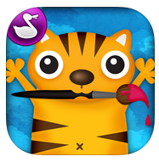

STORY Folder
There are no story apps that must be downloaded in Level 1, but you may like to add any story apps you have to this folder. If you would like to, you could also look at stories in iBooks that would be appropriate.

