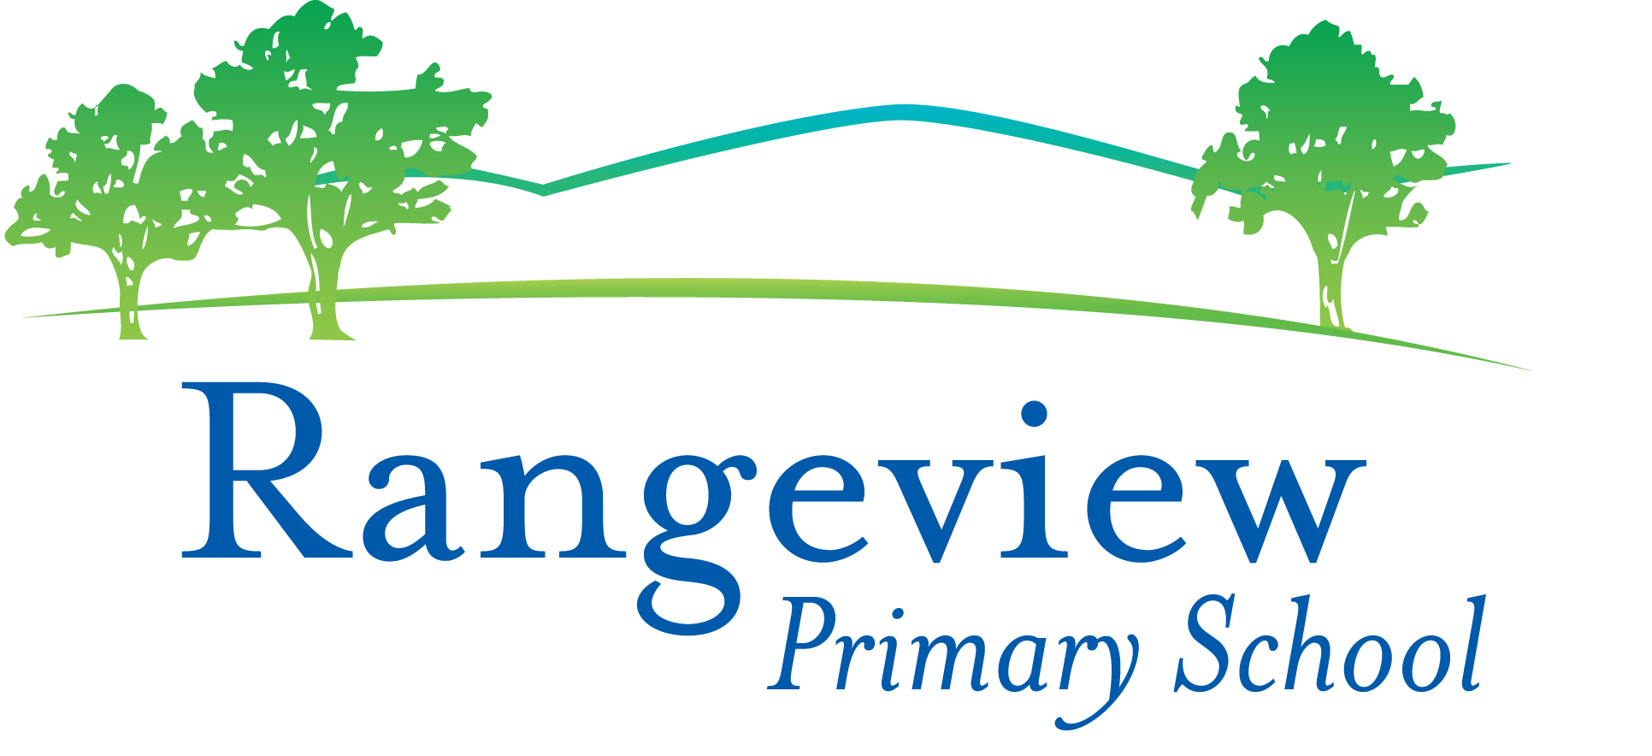
Level 3 App List 2020
Updated 29/01/2020

Many of these Apps are new in Level 3 and will need to be added.
There are essential Apps on the Whole School App List that you should already have. Please check the Whole School App List.
Mathletics, Reading Eggs, iMovie, Seesaw, Book Creator, Popplet and Pic Collage are some of the essential apps from the whole school app list.

PRODUCTIVITY Folder
App | Cost |  | App | Cost
Microsoft OneNote | Free | 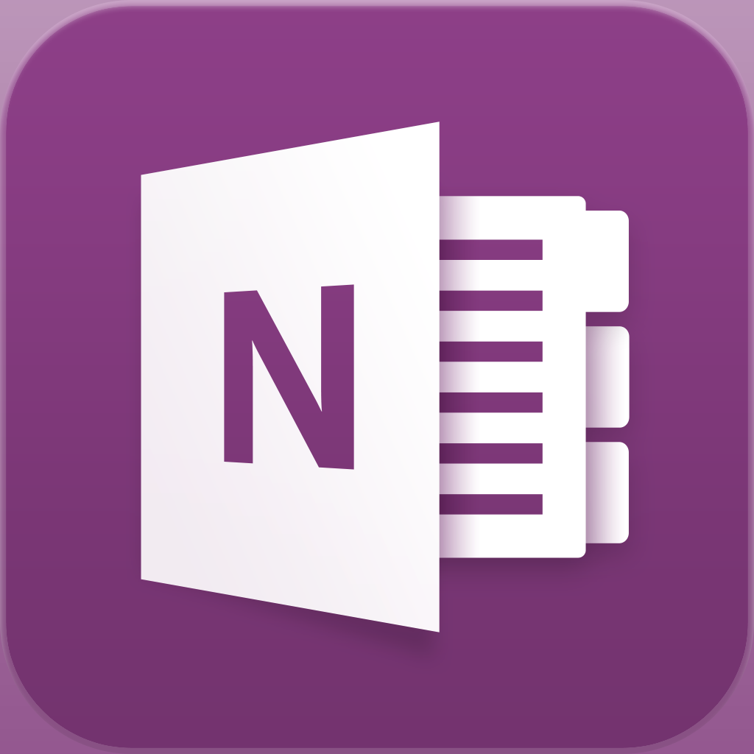 | Microsoft Lens | Free | 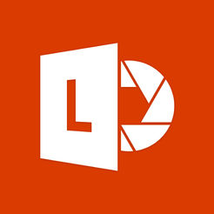
Microsoft Teams | Free | 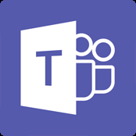 | See Saw | Free | 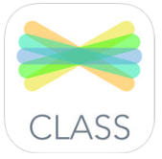

MATHS Folder
Subtraction | Free | 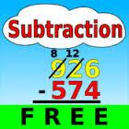 | Number Pieces | Free | 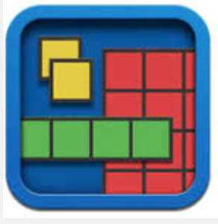
Geoboard | Free | 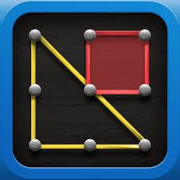 | Hopscotch Coding | Free
Chart Builder | Free | 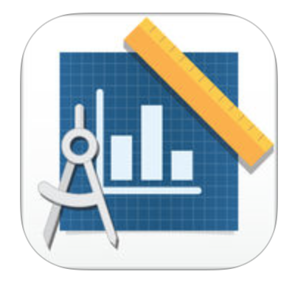 | Tynker  Coding For Kids | Free

ENGLISH Folder

Word Cookies | Free | 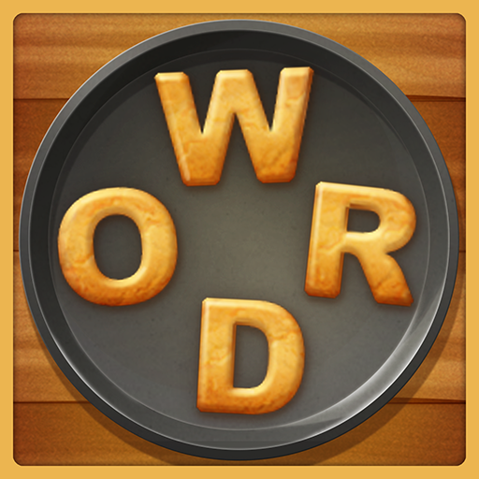 | Spelling bee lists 1000+ | Free | 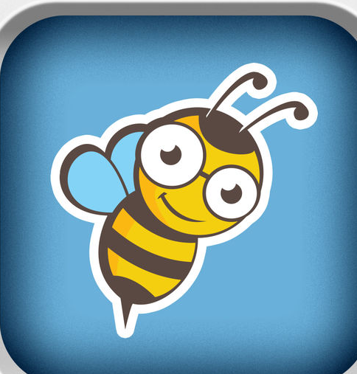
Word Nut | Free | 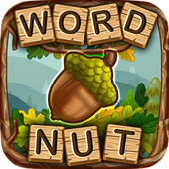 | A+ Spelling Test | Free | 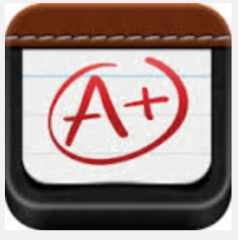

CREATIVITY Folder
Stop Motion  Studio | Free |  | Kahoot | Free
Sphero Edu | Free |  | Minecraft: Education Edition | Free | 