Level 4 App List 2020
Updated 17/12/19

Many of these Apps are new in Level 4 and will need to be added.
There are essential Apps on the Whole School App List that you should already have. Please check this on the Rangeview Website.
Mathletics, Reading Eggs, Quick Voice Recorder, iMovie, Showbie, Book Creator, Popplet and Pic Collage are some of the essential apps from the whole school app list.
PRODUCTIVITY Folder
App | Cost |  | App | Cost
Garage Band | Free |  | See Saw | Free | 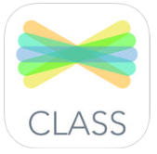
Showbie | Free | 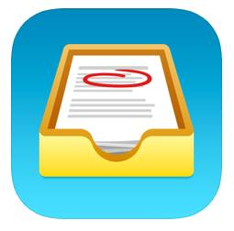 | Microsoft Teams | Free
Microsoft OneNote | Free | 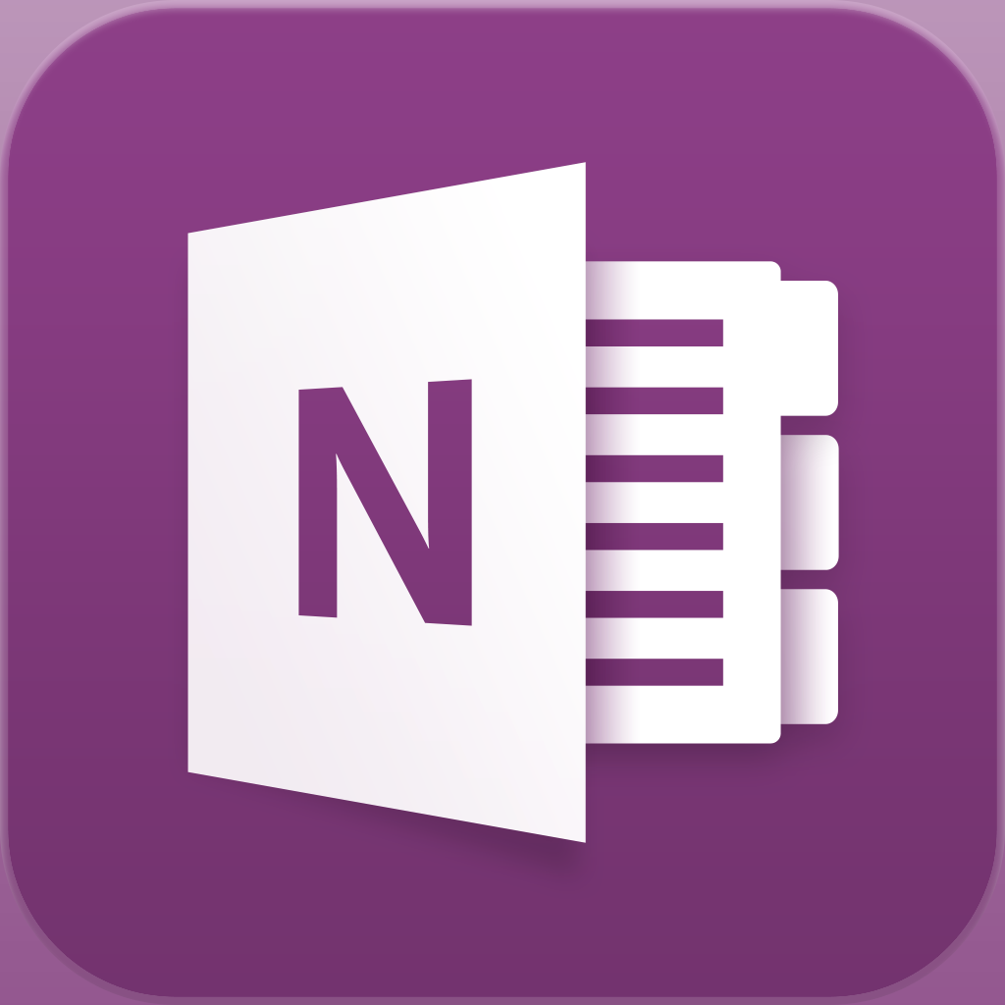 | Microsoft Lens | Free | 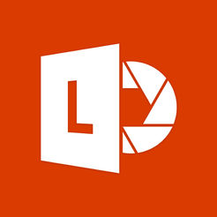

MATHS Folder
Subtraction | Free | 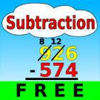 | Number Pieces | Free | 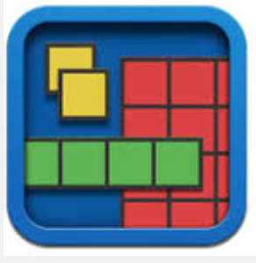
Geoboard | Free | 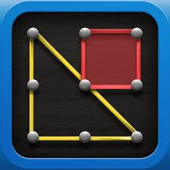 | Hopscotch  coding | Free
Sphero Edu | Free |  | Calculator | free | 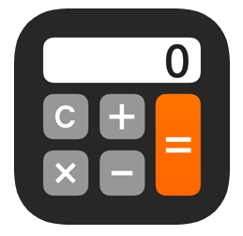
Chart Builder | Free | 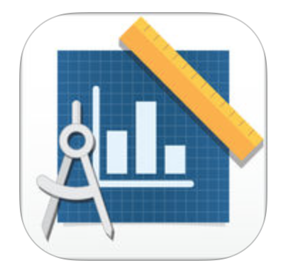 | 2048 | Free
Ollie | Free |  | mBlock Blocky  coding | Free | 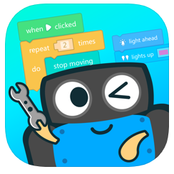

ENGLISH Folder
Wordscapes | Free | 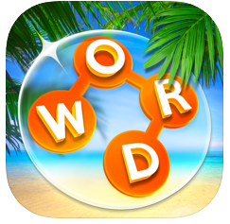 | Spelling bee lists  1000+ | Free
4 Pics 1 Word  Purchase it and then do an in app purchase to upgrade to premium | Free  then $2.99 | 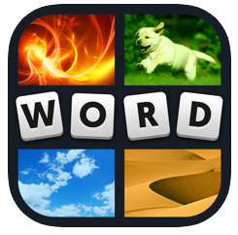 | Simply Voice Dictation | Free | 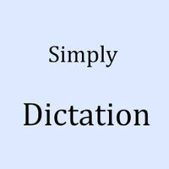
Dictionary.com  Dictionary & Thesaurus  Or the paid version has no advertisements and extra features for $7.99 | Free  Or upgrade $7.99 |  | A+ Spelling Test | Free | 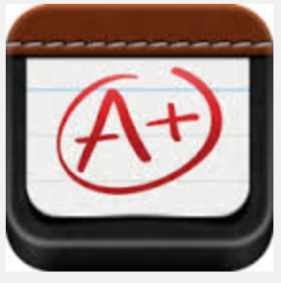

CREATIVITY Folder
Strip Designer | $4.49 |  | Stop Motion  Studio | Free
Staff Wars (music) | $1.49 | 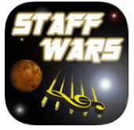 | Qrafter – QR code reader | Free
Kahoot! | Free |  | Pic Collage | Free
Popplet  From previous year’s list | $7.99 |  | Book Creator  From previous year’s list | $7.99 | 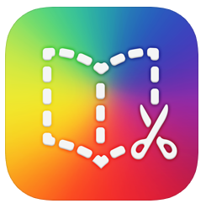
Google Earth | Free |  | Google Maps | Free | 