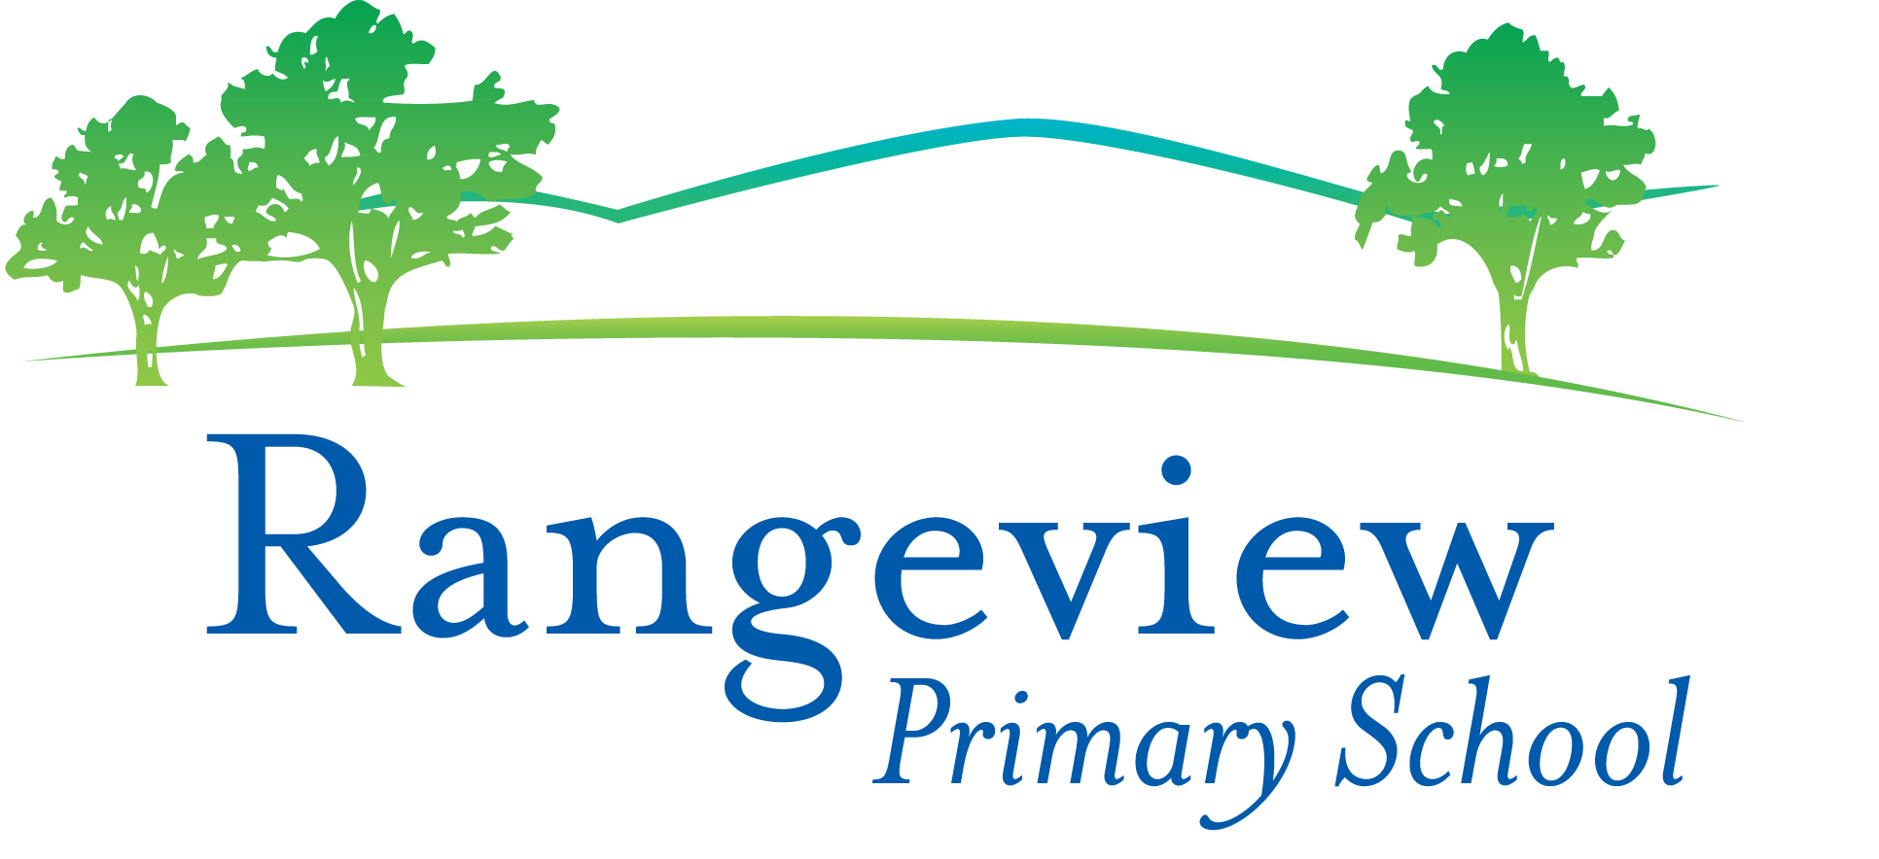
Rangeview Primary School
Whole School App List 2020

All students across the whole school will need these apps.
Updated 28/1/20

App List Information.
Please note that if your child participated in the iPad program last year, you will have many of the apps already.

These Apps are needed and come included with your iPad purchase:
- iMovie
- Pages
- Keynote
- iTunes U
Please ensure these apps are downloaded to your child’s iPad prior to the beginning of Term 1. Please be aware that the price of apps in the App Store may vary slightly over time – these prices were accurate as of 1/1/20
Many of these apps will be used in future years.
If you have more than one child, you only need to purchase an app once and it can be shared across multiple iPads that are linked to the same iTunes account. To do this, select ‘App Store’ on your iPad, go to ‘Purchased’ then select ‘Not on This iPad’. You will then be able to upload the apps on to the iPad.
Some apps are made for iPhone – BUT they can be uploaded onto the iPad. If you cannot find an app, you may need to search under iPhone Apps.
You will see that the apps have been organised into folders.
SETTINGS Folder
App | Cost |  | App | Cost
Find My iPhone  (iPad) | Free | 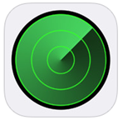

Showbie | Free | 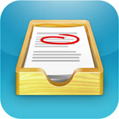 | Seesaw: The Learning Journal  **Download the parent app to your own personal device | Free | 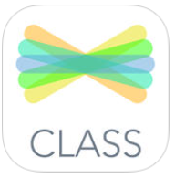
Class Dojo  (Art) | Free |  | Plickers | Free
PRODUCTIVITY Folder

MATHS Folder
Calculator | Free | 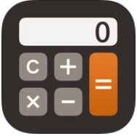 | My Script Calculator | Free | 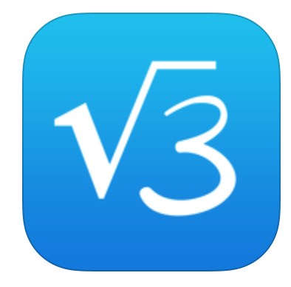
Mathletics | Free | 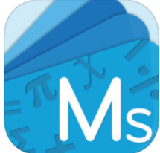 | Pattern Shapes | Free | 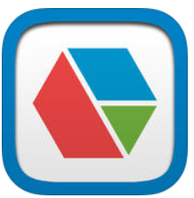

ENGLISH Folder
Reading Eggs | Free | 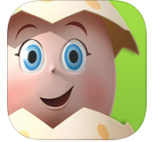

CREATIVITY Folder
Book Creator | $7.99 | 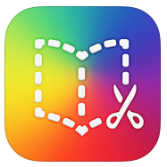 | Show Me Interactive Whiteboard | Free | 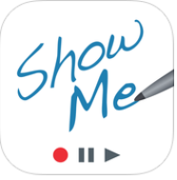
iMovie (if not on your iPad) | $7.99 |  | Doodle Buddy | Free | 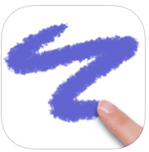
Pic Collage | Free |  | Google Earth | Free | 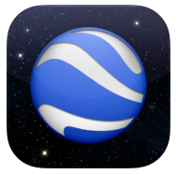
Popplet | $7.99 |  | Qrafter | Free
QuickVoice Recorder | Free

eSmart (Cybersafety) Folder (recommended levels)
Avokiddo emotions (Foundation) | $4.49 | 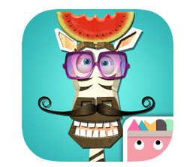 | Wince-Don’t feed the worry bug  (Foundation) | $2.99 | 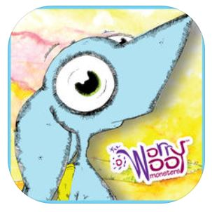
Breathe, Think, Do with Sesame Street  (Foundation) | Free | 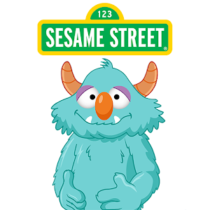 | Zippep’s Astro Circus (Level 1) | Free | 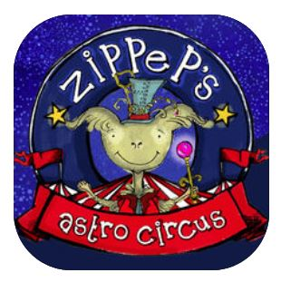
Scratch Jr  (Level F-2) | Free | 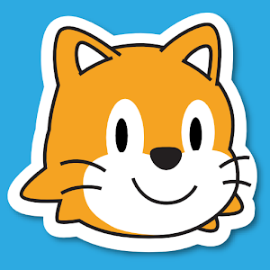 | Daisy the Dinosaur (Level 2) | Free | 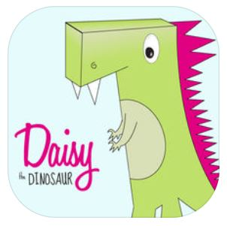
The Allen Adventure  (Level 1-3) | Free |  | Bullying No Way-  Take a stand together  (Level 4) | Free
Tellagami  (Level 5 and 6) | Free |  | Zappar  (Level 5 and 6) | Free | 