WHAT’’’’S HAPPENING IN LEVELS 1 & 2
Welcome back to Rangeview for 2021. We hope that you all had a wonderful holiday and that you are looking forward to this year, as much as we are. The children have settled in their new classes with enthusiasm and are looking forward to exciting learning.
Important Dates:
Monday March 8th Labour Day holiday
Tuesday March 16th School Photo Day
Friday March 5th SEDA Cricket Clinic begins
Friday March 26th Whole school Harmony Day
Thursday April 1st end of Term 1- students dismissed at 2.30 pm
Reader Covers:
Please check last year’s reader cover carefully when it comes home. It may need to be re-covered, and to have the elastic replaced. The children have been given a new record book to keep in their reader covers. Please encourage your child to read aloud to you regularly.
Talk Time: This is a favourite activity and an excellent opportunity for children to gain confidence speaking in front of a group, to develop listening skills and to learn about interesting things. It is wonderful for the class and very good for your child’s self-esteem if all children join in this activity. It works best if some pre-planning is done with your child. The children know their day and weekly topic.

Birthdays: Presently, birthdays are unable to be celebrated at school with food or treats.
iPads: Students are expected to bring their iPad to school each day. Please ensure that it is charged and ready to use.
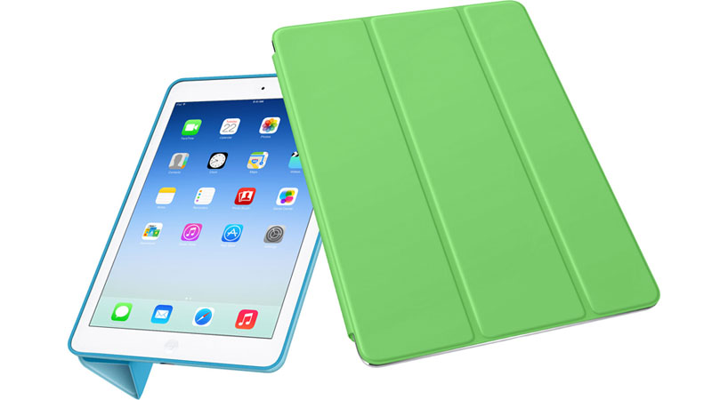

Specialist Timetable: Specialist programs have started and it is wonderful that the children are able to participate in them. We are very lucky at Rangeview to have such a broad range of programs that cater for different interests.

Topics:
During Term 1, Level 1 and 2 classes will be conducting the Start Up program, which aims to build relationships and encourage resilience. This year the whole school is celebrating Harmony Day and students are learning about diversity, inclusion and acceptance. They are exploring different cultures and celebrations and learning how people are the same as / different to one another.

Swimming:
This year swimming is planned for Term 2 at Aquanation, Ringwood. Further details later in the term.

Homework:
Children in Levels 1 and 2 are expected to read their home reading books each day, and to practise their weekly spelling. Your child’s teacher may suggest some extra activities to do at home if necessary.

Spelling:
To make this activity fun and more meaningful, students could make words out of playdough, write them in sand or bean trays, use paintbrushes and water on outside paths, magnetic letters, Magnadoodles, or other tactile activities. Words could be written on a computer/iPad using different fonts and Word Art.
If you feel that your child is already confident with the weekly word list, you can extend your child by using the words as a basis for word building, making word families, collecting words with the same sounds or letter combinations and so on.
Please talk to the teacher if you’d like some more ideas for practising or extending Spelling.

Tissues: As children of this age tend to use a lot of tissues throughout the year, it would be appreciated if each child could bring a large box of tissues to be stored in the classroom.

Lining-up:
Children in Levels 1 and 2 are expected to line up outside each morning to wait for their teachers. They are not to come inside without their teacher prior to the iPad bell at 8.45, even to bring in their readers or schoolbags. At the end of the day, parents are asked to please wait for children outside and not in the corridor, in order to avoid congestion.
Children are expected to be at school at 8:45am, ready for a 9am start to the day. If you are late for any reason, please visit the school office to receive a Late Pass before coming to the classroom.

Absences: Absence notes are expected when your child has been away from school. Please inform the class teacher if your child will be away for an extended period. If children are to be collected before the end of the school day at 3:30 pm, please go to the office first to collect a pass to hand to the class teacher.

Reminders: All children are expected to wear school hats. Please check to make sure that your child’s name and class is clearly visible on the hat, and on all other items of clothing and belongings.

Any medication that your child needs to take must be given to the office staff with written instructions. Your child’s teacher is not able to administer medication of any kind, even with parental permission.
Please remember, even though the teachers throughout Levels 1 and 2 are teaching the same curriculum, each teacher has an individual approach, and some activities may be taught slightly differently.
Please don’t hesitate to make an appointment to talk to any of our team if you have any concerns. We’re all expecting 2021 to be a great year in Level 1 and 2.

Level 1 and 2 Team:

Linda Giardino/Natalie Bellis Melissa Dann/Natalie Low

Rebecca Gordon/Kyla Petrilli Nicole/Jackie Moran Danielle Anderson

Marita Horvath Marianne Kehoe Sam Anderson Josh Godwin

