Level 2 App List 2021
Updated 30/1/17 Updated 22/1/2021
You will see that the Apps have been organised into folders. Please create or update these folders and put the apps in the appropriate folder: MATHS, WORD WORK / ENGLISH, STORY, CREATIVITY, SETTINGS, PRODUCTIVITY. Please put all other apps into the SETTINGS folder or UTILITIES folder. You may like to create a HOME folder for apps you use at home.
Please put the Safari icon, the Camera icon and See Saw icon on the bottom bar of the iPad.
There are essential Apps on the Whole School App List that you should already have. Please check this on the Rangeview Website. Mathletics, Reading Eggs, Quick Voice Recorder, Book Creator, Popplet and Pic Collage are some of the essential apps from the whole school app list.
To create a folder, press and hold one of the apps so that they start to shake. You can then:
- Create a folder by dragging and then holding one app on top of another. You can then rename the folder.
- Add an app to a folder by dragging an app so that it is on top of a folder
When you've finished, press the Home button to stop the shaking.
App | Cost |  | App | Cost
100 Yay!  (From Level 1) | Free | 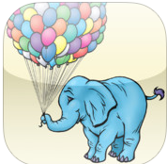 | Mad Math 2  (From Level 1) | $2.49 | 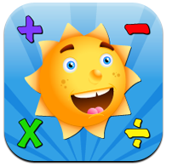
Number Pieces by MLC (From Level 1) | Free | 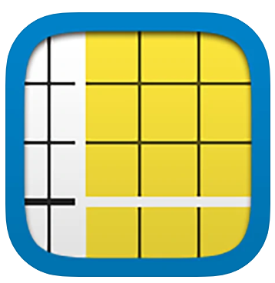 | Find Sums  **search for this under iPhone app  (From Level 1) | Free | 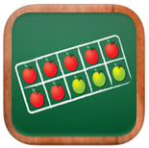
Scratch Jnr  (From Level 1) | Free | 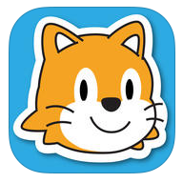 | Pattern Shapes | Free | 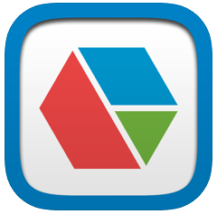
MATHS Folder

WORD WORK / ENGLISH Folder
rED Writing  (From Foundation) | $4.49 | 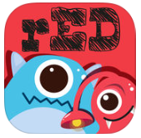 | Write About This | $5.99 | 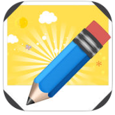
Rhyming Bee  (From Level 1) | Free | 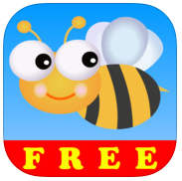 | Letters and Numbers Tracing | Free | 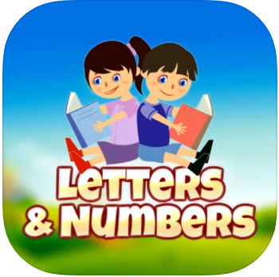
Phonics Fun 4  (From Level 1) | Free | 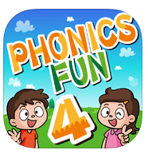 | Phonics Fun 5  (From Level 1) | Free | 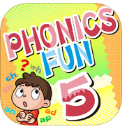
Phonics Fun 6  (From Level 1) | Free | 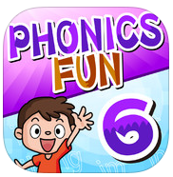 | Montessori Rhyme time  (From Level 1) | Free | 