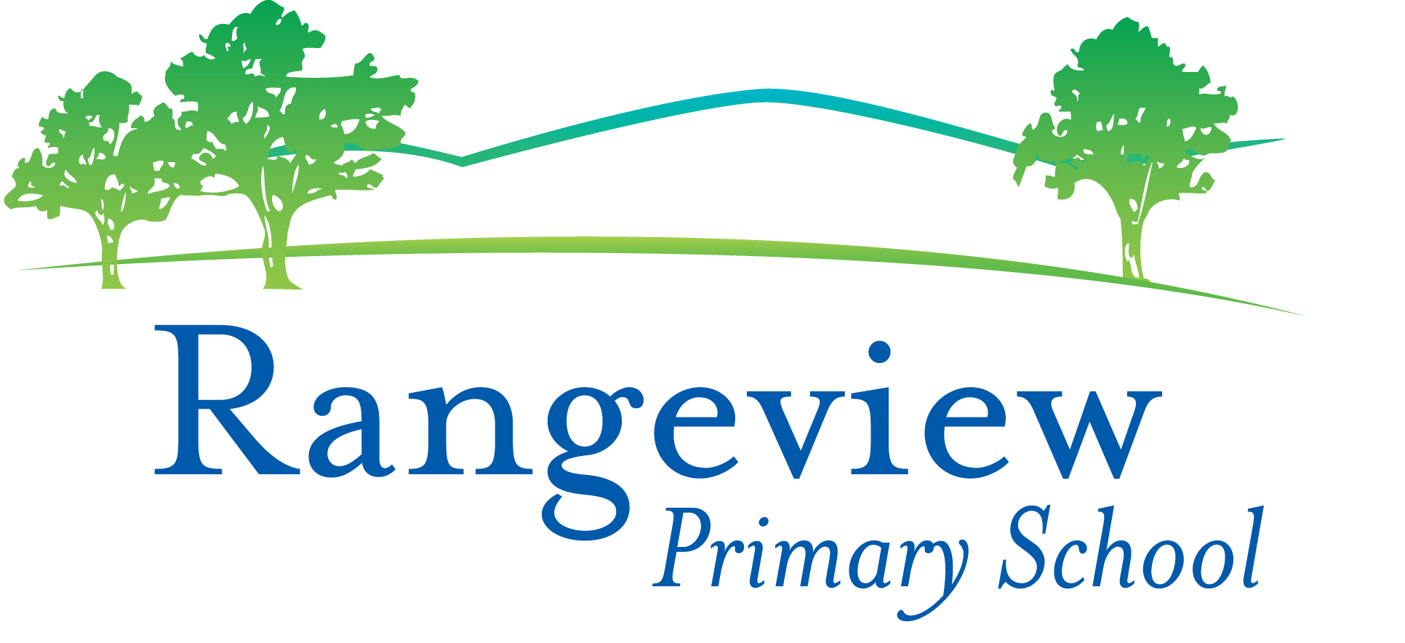
Level 3 App List 2021
Updated 22/1/2021

Many of these Apps are new in Level 3 and will need to be added.
There are essential Apps on the Whole School App List that you should already have. Please check the Whole School App List.
Mathletics, Reading Eggs, Quick Voice Recorder, iMovie, Seesaw, Book Creator, Popplet and Pic Collage are some of the essential apps from the whole school app list.

PRODUCTIVITY Folder
App | Cost |  | App | Cost
Seesaw | Free | 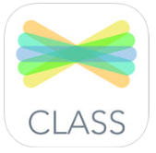

MATHS Folder
Subtraction! | Free | 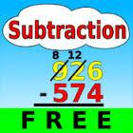 | Number Pieces by MLC | Free | 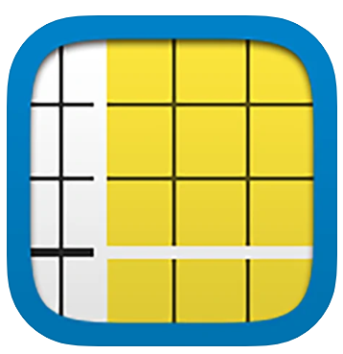
Geoboard | Free | 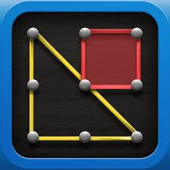 | Hopscotch Coding | Free
Chart Builder | Free | 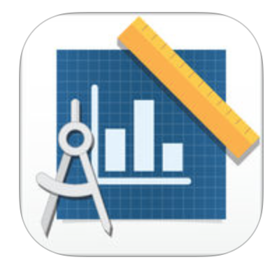 | Tynker  Coding For Kids | Free

ENGLISH Folder

Word Cookies | Free |  | Spelling bee lists 1000+ | Free | 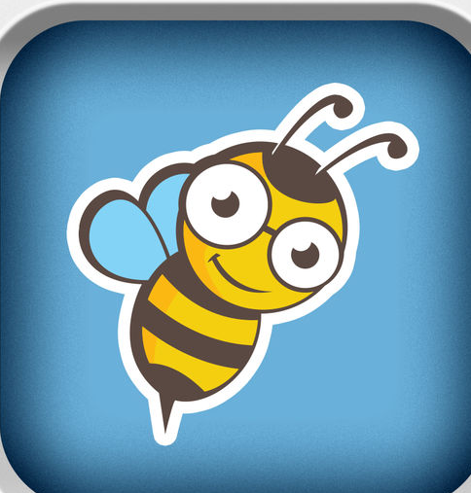
Word Nut | Free | 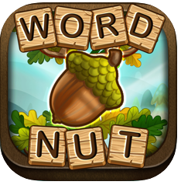 | A+ Spelling Test | Free | 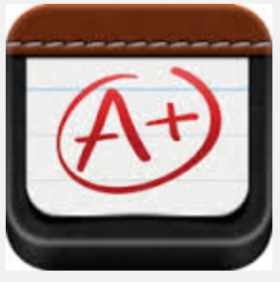

CREATIVITY Folder
Stop Motion  Studio | Free | 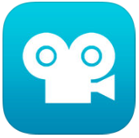 | Kahoot | Free | 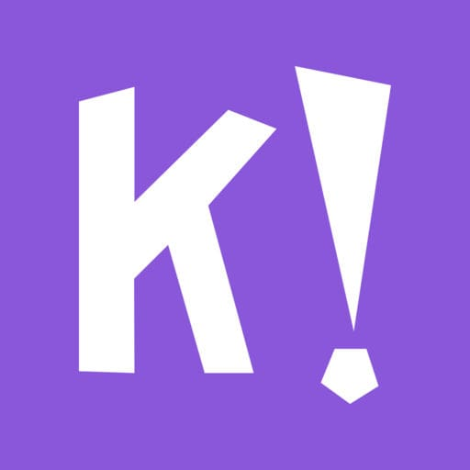
Sphero Edu | Free |  | Minecraft: Education Edition | Free | 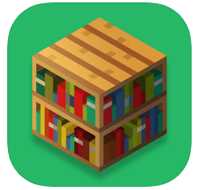
Qrafter – QR code reader | Free |  | Pic Collage | Free
Popplet  (Whole School App List) | $4.49 |  | Google Earth | Free | 