Level 5 and 6 App List 2021
Updated 22/01/2021

Some of these Apps are new in Level 5 and 6 and will need to be added.
There are essential Apps on the Whole School App List that you should already have. Please check this on the Rangeview Website.
Mathletics, Reading Eggs, Quick Voice Recorder, iMovie, Showbie, Book Creator, Popplet and Pic Collage are some of the essential apps from the whole school app list.

PRODUCTIVITY Folder
App | Cost |  | App | Cost
Evernote | Free |  | Edmodo | Free

MATHS Folder
Hopscotch | Free |  | Math Vocabulary Cards | Free | 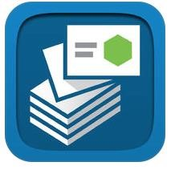
Luminosity – Brian Training | Free |  | Sudoku (Full version) by Genina | Free | 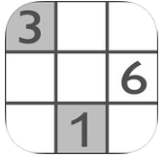

ENGLISH Folder
Dictionary.com  Dictionary & Thesaurus  (from Level 3/4 list) | Free

CREATIVITY Folder
Kahoot! – Play Learning Games | Free |  | Stop Motion  (from Level 3/4 list) | Free
EV3 Programmer  (Digital Technologies) | Free | 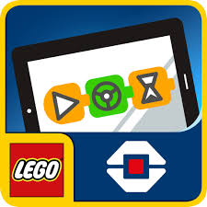 | Garage Band | Free

HUMANITIES Folder
Google Maps | Free | 