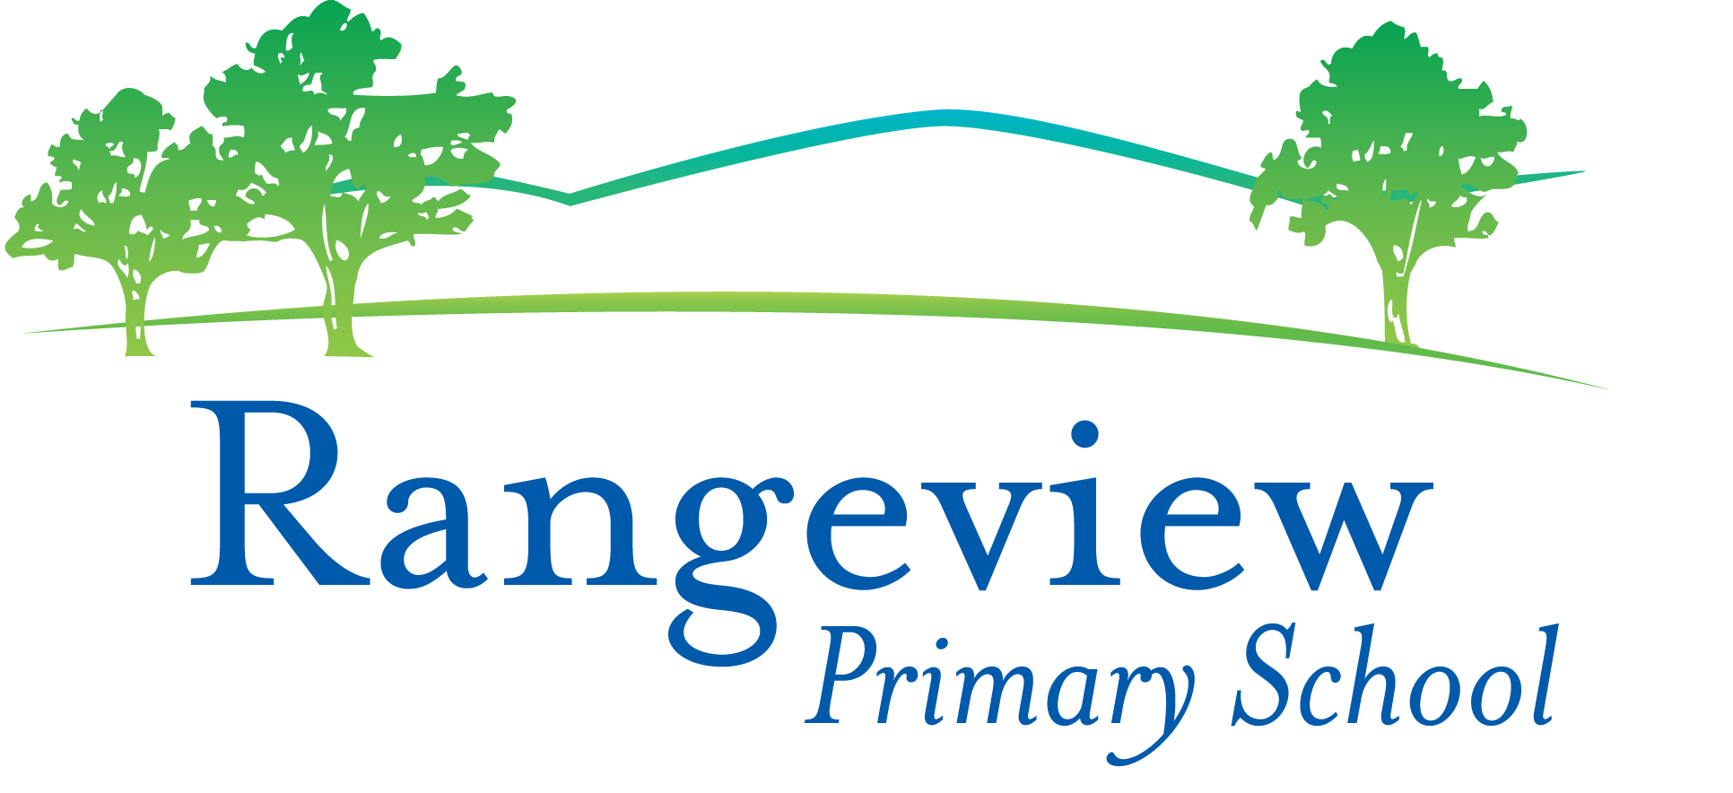
Rangeview Primary School
Strategic Plan 2018 – 2021 and Annual Implementation Plan 2021
School Strategic Plan 2018 – 2021

Goal 1: To maximise learning growth for every student across the curriculum.

NAPLAN  2021 Targets | In Top 2 Bands  Year 3 | In Top 2 Bands  Year 5 | Making Relative High Growth  Year 5 |  | School Staff Survey | 2021 Targets
Reading | 80% | 70% | 30% |  | Collective Efficacy | 85%
Writing | 70% | 40% | 33% |  | Collective Responsibility | 95%
Spelling | 75% | 55% |  |  | Academic Emphasis | 85%
Numeracy | 78% | 60% | 42% |  | Teacher Collaboration | 75%
 |  |  |  |  | Shielding / Buffering | 60%
 |  |  |  |  | School Level Support | 75%
 |  |  |  |  | Overall School Climate | 80%

Goal 2: To enhance wellbeing, foster an inclusive and respectful culture that celebrates diversity.

Student Attitudes to School Survey | 2021 Targets |  | Parent Opinion Survey | 2021 Targets
Classroom Behaviour | 75% |  | Parent Participation and Involvement | 87%
Resilience | 78% |  | Teacher Communication | 71%
School Connectedness | 77% |  | School Improvement | 75%
Respect for Diversity | 72% |  | Confidence and Resiliency Skills | 87%
Managing Bullying | 69% |  | Experience of Bullying | 50%
Non-Experience of Bullying | 79% |  | Respect for Diversity | 87%
 |  |  | Promoting Positive Behaviour | 87%

Goal 3: To develop student agency and an understanding of themselves as learners.

Student Attitudes to School Survey | 2021 Targets |  | Parent Opinion Survey | 2021 Targets |  | School Staff Survey | 2021 Targets
Motivation and Interest | 87% |  | Teacher Communication | 71% |  | Collective Efficacy | 80%
Self-Regulation and Goal Setting | 90% |  | Student Motivation and Support | 73% |  | Collective Responsibility | 95%
Learning Confidence | 78% |  | Effective Teaching | 83% |  | Academic Emphasis | 73%
Student Voice and Agency | 66% |  | Student Agency and Voice | 81% |  | School Level Support | 65%
Classroom Behaviour | 73%

Annual Implementation Plan 2021
Goal 1: 2021 Priorities Goal: Monitoring all student assessment 6 to 12 months growth in Numeracy and Literacy.
Monitor and respond to student health and wellbeing concerns. Strengthen and embed connections between students and
school and between parents and carers and school.

To maximise learning growth for every student across the curriculum.
NAPLAN top 2 bands as follows:
Reading Year 3 80%, Year 5 70%, Writing Year 3 70%, Year 5 40%, Numeracy Year 3 78% Year 5 60%, Spelling Year 3 75% Year 3 55%

- Key Improvement Strategy 1 – Learning catch-up and extension priority.
Building teacher capability to deliver targeted student support in literacy and numeracy with a focus on Reader's Workshop.
Embed Writer’s workshop.
Tutoring program 2021.

- Key Improvement Strategy 2 – Happy, active and healthy kids priority.
Establish an agreed approach to monitoring and responding to student mental health & wellbeing concerns.
Introduce the new schoolwide Student Behaviour Support Model 2021.
Continue to embed the Rangeview Wellbeing Model (Tier System)
Design new Student Wellbeing Survey F - 6 and implement as pre and post wellbeing measure.

- Key Improvement Strategy 3 – Connected schools priority.
Strengthen & embed the connection with parents/carers developed during remote and flexible learning.

Goal 2: To enhance wellbeing, foster an inclusive and respectful culture that celebrates diversity.

To improve the Student Attitudes to School Survey as follows:
Classroom Behaviour 75%, Resilience 78%, School Connectedness 77%, Respect for Diversity 72%, Managing Bullying 69%, Non-Experience of Bullying 79%

- Key Improvement Strategy 1 – As a lead school in the Rights, Resilience and Respectful Relationships initiative, the school will lead a COP group of partner schools to
develop, deliver and embed the RRRR model. The Rights, Resilience and Respectful Relationships model will continue to be taught and
further embedded across the school.

- Key Improvement Strategy 2 – Students will investigate the concept of ethnicity and ability diversity to deepen their understanding of the world and their
place in it as global citizens.
A partnership forged with Eastwood Primary School will be further developed.

